CHAPTER 1

INTRODUCTION

The project “NETWORK LOAD BALANCING” is designed
using Microsoft Visual Studio.Net 2008 as front end and Microsoft SQL Server 2005 as back end which works in .Net framework version 2.0. The coding language used is VB .Net.

Many distributed real-time applications, such as audio- and video-conferencing, require the network to construct a multicast path (tree) from a sender to multiple receivers. Furthermore, real-time applications have Quality-of-Service (QoS) requirements (e.g. bandwidth). The objective of the routing protocol is to build a tree that is both feasible (i.e. satisfies the requested QoS) and least costly. The cost of a tree depends on the costs of its links. The cost of a link should reflect the effect of allocating resources to the new connection on existing and future connections. Many studies have proposed multicast algorithms to construct low-cost QoS-constrained trees. However, these studies assume that some cost is given for each link, and they do not examine the effect of the link cost function. In this paper, we examine the effect of various link cost functions on the performance of two classes of multicast routing algorithms under both uniform and skewed real-time workload. We also investigate the impact of inaccurate network state information. Our simulation results show that when network state information is accurate (most up-to-date) at each router, the choice of the link cost function only has a negligible effect, if any, on the routing performance. More interestingly, we find that, a link cost function that is more sensitive to load performs better when link state information is relatively accurate, while when link state information is more stale, a link cost function that is less sensitive to load performs better. This is more pronounced under higher load and when multicast groups are denser.

1.2 Project Description

The project “NETWORK LOAD BALANCING” is designed
using Microsoft Visual Studio.Net 2005 as front end and Microsoft SQL Server 2000 as back end which works in .Net framework version 2.0. The coding language used is VB .Net.

Modules

- Authentication Module.
- IP Address Representation Module.
- Load Servers Module.
- Load Balancing Module.
- Report Module

Authentication Module:

The authentication module is to register the new users and previously registered users can enter into our project. The admin only can enter and do the uploading files into the servers. After login by every user and the admin the sql server checks the login id and password is valid or not. If the login is not valid it displays that the login is not correct.

IP Address Representation Module:

The IP Address Representation module is to give the IP addresses which we are going to assign those as servers. We can enter and view IP addresses from this module. In load balancing system we can connect the three servers [system]. The connection has to be represented by the IP Address representation only.

Load Servers Module:

The Load Servers module has the authentication for the administrator only can enter into this module. The administrator will do the encryption of the text file and store into the servers which we are assigned in IP representation module. This module will make the both public and private key for the cryptography.

Load Balancing Module:

The Load Balancing module has the authentication for users can enter into the upload page and can view the file name which the administrator stored into the servers. The user can select the file from the list and can download from the server which is in idle state. We will get the response time and from which server we are getting the file. Finally we can get the decrypted file from the key pair.

Report Module:

We will get the response time and from which server we are getting the file. From the response time produce the chart report here. It compares the response time between the servers and download the given file in the better performance response time server.

Sample Input and Output:

Input text file is given by admin and the encrypted format is stored in all servers. Output is decrypted file from the server which is in idle state. And it produce response time chart.

CHAPTER 2

SOFTWARE PROJECT PLAN

This chapter discuss about that time schedule for the project and it contain the various phases of the project
.
The Various Phases of the Project:

S.NO | TASK | DURATION
1 | Requirement Specification | 10 Day’s
2 | Requirement document specification | 10 Day’s
3 | Design analysis | 20 Day’s
4 | Design Documentation | 15 Day’s
5 | Design Review | 20 Day’s
6 | Coding | 15 Day’s
 | Total | 90 Day’s

CHAPTER 3
CUSTOMER REQUIREMENTS DETERMINATION

3.1 EXISTING SYSTEM

- In existing system, they have used to develop the project using Round Robin [RR] model and SSL_with_Session model. Those models are not effective. Those models are not able to give the out put in time and the thorough put also lesser than that their expected output.
- These models had made the Latency problem and minimal through put. For this problem they introduced the SSL_with_bf (Backend forwarding) model is to overcome the existing problems. We going to implement SSL_with_Backend Forwarding model in our proposed system.

3.2 PROPOSED SYSTEM

- In our Proposed System, We are going to implement the SSL_with_Backend Forwarding model (Algorithm) is to overcome the problem of existing system.
- This model will reduce the latency and increase the throughput than the existing system (Round Robin model and SSL_with_Session).
- The Secure Socket Layer_with_BF model is very helpful for load balancing of the server. This will reduce the load of the server while the server is being busy. These are the advantages of our proposed system.
- The ssl_with_bf scheme can minimize the average latency by about 40 percent and improve throughput across a variety of workloads.

CHAPTER 4

SYSTEM REQUIREMENTS SPECIFICATION

Software Requirements Specification (SRS) is the starting point of the software development activity. Little importance was given to this phases in the early days of software development. The emphasis was first on coding and then shifted to design.
As systems grew more complex, it become evident that the goal of the entire system cannot be easily comprehended. Hence need for the requirements analysis phase arose. Now, for large software systems, requirements analysis is perhaps the most difficult activity and also the most error prone.

Some of the difficulty is due to the scope of this phase. The software project is imitated by the client needs. In the beginning these needs are in the minds of various people in the client organization. The requirement analyst has to identify the requirements by tacking to these people and understanding there needs. In situations where the software is to automated a currently manuals process, most of the needs can be understood by observing the current practice.

The SRS is a means of translating the ideas in the minds of the clients (the output) into formal document (the output of the requirements phase). Thus the output of the phase is a set of formally specified requirements, which hopefully are complete and consistent, while the input has none of these properties.

4.1 Functional Requirements

Ssl_with_bf Response time

Server 1

Server 3

Server 2

Client
Upload or Download

4.2 Performance Requirements
The project must the end user requirements. Accuracy and fast must be imposed in the project.
The project is development as easy as possible for the sake of end user. The project has to be developed with view of satisfying the future requirements and future enhancement.
This processing as well as tine taken to generate well reports where also even when large amount of data was used. The system is designed in such a way that even when large amount of data used for processing there would less performance degradation.

4.3 Interface requirements
4.3.1 Hardware Interface
The stranded input device like keyboard and mouse are to get input. The output will be generated and display in the monitor. The reports can also be exported to a SQL-server document are text file. The stranded printer in used to take outputs.
4.3.2 Software Interface
The design part and interface id done the front end ASP.Net and SQL server as a backend of the project.
4.4 Operational requirements
The database or databases that are being failed over to the stand by server cannot be used for anything else.but databases on the standby server not being used for failover can still be used normally.
When it comes time for actual failover,you much one of two things to make your application work either rename the standby server the same name as the failed production server(and the IP address),or re-point your user’s applications to new standby server.in some cases,neither of this option is practical.

4.5 Resource Requirements
4.5.1 Hardware REQUIREMENTS:
The hardware used for the development of the project is:

PROCESSOR : PENTIUM III 866 MHz
RAM : 128 MD SD RAM
MONITOR : 15” COLOR
HARD DISK : 20 GB
FLOPPY DRIVE : 1.44 MB
CDDRIVE : LG 52X
KEYBOARD : STANDARD 102 KEYS
MOUSE : 3 BUTTONS

4.5.2 Software rEQUIREMENTS:

The Software used for the development of the project is:

OPERATING SYSTEM : Windows XP
ENVIRONMENT : Visual Studio .NET 2005
.NET FRAMEWORK : Version 2.0
LANGUAGE : VB.NET
BACK END : SQL SERVER 2000

4.6 Security Requirements
Web application are available via network access, it is a difficult. If not possible, to limit the populatin of the end-user who may access the applications? In order to product sensitive connect and provide secure mode be implemented throughout the infrastructure that the supports web application and within the application itself.
Web Application have become heavy integrated with critical corporate and database. E-commerce application extracts and then store sensitive customer information.
.
4.7 Design Requirements
To create project, add base masters and masters to the project, assign behaviors to the master, create and assign behavior sets, and then apply, test and validate those behaviors. It also shows how to create and build a stencil to hold the shapes.

4.8 Quality and Reliability Requirements
A software component that is developed for reuse would be correct and would contain no defects. In reality, formal verification is not carried out routinely, and defects can add to occur.However,with each reuse, defects are found eliminated, and a components qualify improve as a result. Over time the components virtually defect free.
Software reliability is defined in statical term as” the probability of faultier-free operation of a computer program in a specified environment for specified tine”. The software quality and reliability ,failure is nonconformance to software requirements.

Web Correct link processing
Application Reliability Error recovery
Quality Input validation and recovery

CHAPTER 5

SYSTEM ANALYSIS

In this section discussed about data flow diagram, Entity relationship diagram. These things are represented as diagrams with proper notation.

5.1 Data Flow Diagram

The data flow diagram is one of the most improvement tools used by the system analyst DeMacro (1978) Nad Gand Sarson (1979) popularized the use if the data flow diagram as modeling tools through their structured system analysis methodologies.
A data flow diagram should be the first tool used by system analyst to model system components. These components are the system processes; the data used by this processes and external entities that interact with the system and the information flows in the system.

5.1.1. Process

Process show what system does. Each process has one or more data inputs and produce one or more data output, Circles in a data flow diagram represent process. Each process has unique name and number. This name and number appear inside the circle that represents the processes in a data flow diagram.

This process is represented as circle

5.1.2. Data Stores:

File or data store is depositary of data. They contain data that is retained in the system. Processes can enter the data into a data store or retrieve data from the data store. Each data store is represented by thin line in the data flow diagram and each data store has a unique name.
The data store is represented in form of a line

5.1.2 External Entities:

External entities are outside the system but they either supply input data into the system or use the system output, they are entities which the designer has no control. Square or rectangle may represent external entities that supply data into a system or some times called sources. External entities that use the system data are sometimes called sinks.

5.1.4 Data Flows:

Dataflow model the passage of data in the system and are represented lines joining system components. An arrow indicates the direction of the flow and the line labeled by the name of the data flow.

5.1 Data Flow Diagram
Ssl_with_bf Response time

Server 1

Server 3

Server 2

Client
Upload or Download

5.2 Use Case Diagram

Server 1

Server 2

Server 3

Server
Upload or download
Connect to server
Which is free?

5.3 ER DIAGRAM
Home
Admin
User Registration
& Login
Upload file
Server 1
Server 2
Server 3
IP Representation
View IP addresses
View uploaded filenames
Browse
Download selected file
Request
Response
Send req. which server is free
Response time and from which server we are getting.

5.2 Software Life Cycle
Title Submission
Authorization Certificate
Students
Training
Problem Analysis:
Online Discuss-Forum
Front-end Asp.net
Back-end: SQL Server
Code behind: C#.net
Networking Design:
Internet Explorer 6.0
Coding
Validation
Testing
Document
Reports
Certificate
Complete Certificate
Programmer Training Certificate
Authorization Signatory
Learning Process
DB
CHAPTER 6
SYSTEM DESIGN
Design is multi-step process that focuses on data structure software architecture, procedural details, (algorithms etc.) and interface between modules. The design process also translates the requirements into the presentation of software that can be accessed for quality before coding begins.
Computer software design changes continuously as new methods; better analysis and broader understanding evolved. Software Design is at relatively early stage in its revolution.
5.1INPUT DESIGN 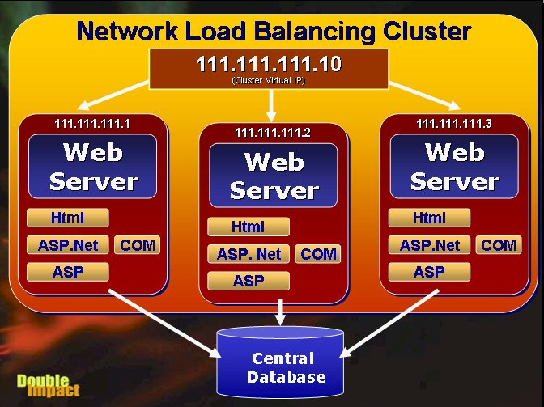

Network Load Balancing facilitates the process of creating a Web Server Farm. A Web Server farm is a redundant cluster of several Web servers serving a single IP address. The most common scenario is that each of the servers is identically configured running the Web server and whatever local Web applications running on the Web server as shown in Figure 1. Each machine has its own copy of everything it needs to run the Web application which includes the HTML files, any script pages (ASP, ASP.Net), any binary files (such as compiled .Net assemblies, COM objects or DLLs loaded from the Web app) and any support files such as configuration and local data files (if any). In short the application should be fully self-contained on a single machine, except for the data which is shared in a central location. Data typically resides in a SQL backend of some sort somewhere on the network, but could also be files shared in a directory for files from a file based database engine such as Visual FoxPro or Access.

Each server in the cluster is fully self-contained, which means it should be able to function without any other in the cluster with the exception of the database (which is not part of the NLB cluster). This means each server must be configured separately and run the Web server as well as any Web server applications that are running. If you're running a static site, all HTML files and images must be replicated across servers. If you’re using ASP or ASP.Net, those ASP pages and all associated binaries and support files must also be replicated. Source control programs like Visual SourceSafe can make this process relatively painless by allowing you to deploy updated files of a project (in Visual Studio.Net or FrontPage for example) to multiple locations simultaneously.

Short of the data everything else is running on all of the machines in the NLB cluster. The key is redundancy in addition to load balancing – if any machine in the cluster goes down, NLB will re-balance the incoming requests to the still running servers in the cluster. The servers in the cluster need to be able to communicate with each other to exchange information about their current processor and network load and even more basic checks to see if a server went down.

If you have COM components as part of your Web application things get more complicated, since the COM objects must be installed and configured on each of the servers. This isn't as simple as copying the file, but also requires re-registering the components, plus potentially moving any additional support files (DLLs, configuration files if needed, non-sql data files etc.). In addition, if you're using In-Process components you'll have to shut down the Web server to unload the components. You'll likely want to set up some scripts or batch files to perform these tasks in an automated fashion pulling update files from a central deployment server. You can use the Windows Scripting Host (.vbs or .js files) along with the IIS Admin objects to automate much of this process. This is often tricky and can be a major job especially if you have a large number of cluster nodes and updates are frequent – strict operational rules are often required to make this process reliable. Luckily if you’re building applications with pure ASP.Net you won’t have these issues since ASP.Net can update .Net binary files without any shutdowns by detecting changes to the source files and shadow copying binary files to a different directory for execution.

5.2 OUTPUT DESIGN
Network Load Balancing scales the performance of a server-based program, such as a Web server, by distributing its client requests among multiple servers within the cluster. With Network Load Balancing, each incoming IP packet is received by each host, but only accepted by the intended recipient. The cluster hosts concurrently respond to different client requests, even multiple requests from the same client. For example, a Web browser may obtain the various images within a single Web page from different hosts in a load-balanced cluster. This speeds up processing and shortens the response time to clients.
Each Network Load Balancing host can specify the load percentage that it will handle, or the load can be equally distributed among all of the hosts. Using these load percentages, each Network Load Balancing server selects and handles a portion of the workload. Clients are statistically distributed among cluster hosts so that each server receives its percentage of incoming requests. This load balance dynamically changes when hosts enter or leave the cluster. In this version, the load balance does not change in response to varying server loads (such as CPU or memory usage). For applications, such as Web servers, which have numerous clients and relatively short-lived client requests, the ability of Network Load Balancing to distribute workload through statistical mapping efficiently balances loads and provides fast response to cluster changes.
Network Load Balancing cluster servers emit a heartbeat message to other hosts in the cluster, and listen for the heartbeat of other hosts. If a server in a cluster fails, the remaining hosts adjust and redistribute the workload while maintaining continuous service to their clients. Although existing connections to an offline host are lost, the Internet services nevertheless remain continuously available. In most cases (for example, with Web servers), client software automatically retries the failed connections, and the clients experience only a few seconds' delay in receiving a response.

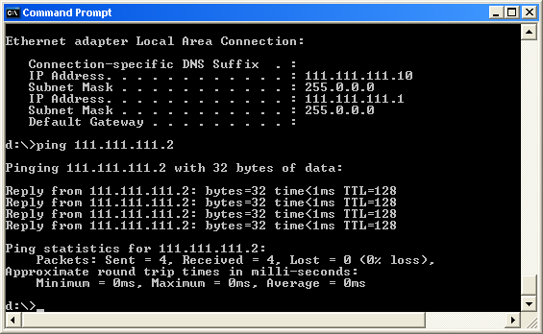

6.3 Interface Design
The ODBC (Open Database Connectivity) interface is a pure .NET to execute SQl statement. The ODBC provides a set classes and interfaces that can be used by developers to write database applications. Basic ODBC interactions in its simplest form, can be broken down into four steps:

1. Open a connection to the database.
2. Execute a SQL statement
3. Process the result
4. Close the connection to the database
Database Design

The database design is a must for any application developed especially more for the data store projects. Since the chatting method involves storing the message in the table and produced to the sender and receiver, proper handling of the table is a must.

In the project, login table is designed to be unique in accepting the username and the length of the username and password should be greater than zero.

The complete listing of the tables and their fields are provided in the annexure under the title ‘Table Structure’.

The .Net Framework

The .NET Framework is a new computing platform that simplifies application development in the highly distributed environment of the Internet.

Objectives of. Net framework:
1. To provide a consistent object-oriented programming environment whether object codes is stored and executed locally on Internet-distributed, or executed remotely.

2. To provide a code-execution environment to minimizes software deployment and guarantees safe execution of code.

3. Eliminates the performance problems.

There are different types of application, such as Windows-based applications and Web-based applications.

To make communication on distributed environment to ensure that code be accessed by the .NET Framework can integrate with any other code.

Components Of .Net Framework

1. The Common Language Runtime (CLR):
The common language runtime is the foundation of the .NET Framework. It manages code at execution time, providing important services such as memory management, thread management, and remoting and also ensures more security and robustness. The concept of code management is a fundamental principle of the runtime. Code that targets the runtime is known as managed code, while code that does not target the runtime is known as unmanaged code.

The .Net Frame Work Class Library:
It is a comprehensive, object-oriented collection of reusable types used to develop applications ranging from traditional command-line or graphical user interface (GUI) applications to applications based on the latest innovations provided by ASP.NET, such as Web Forms and XML Web services.

The .NET Framework can be hosted by unmanaged components that load the common language runtime into their processes and initiate the execution of managed code, thereby creating a software environment that can exploit both managed and unmanaged features. The .NET Framework not only provides several runtime hosts, but also supports the development of third-party runtime hosts.

Internet Explorer is an example of an unmanaged application that hosts the runtime (in the form of a MIME type extension). Using Internet Explorer to host the runtime to enables embeds managed components or Windows Forms controls in HTML documents.

FEATURES OF THE COMMON LANGUAGE RUNTIME:
The common language runtime manages memory; thread execution, code execution, code safety verification, compilation, and other system services these are all run on CLR.
Security.
Robustness.
Productivity.
Performance.
Security:
The runtime enforces code access security. The security features of the runtime thus enable legitimate Internet-deployed software to be exceptionally feature rich. With regards to security, managed components are awarded varying degrees of trust, depending on a number of factors that include their origin to perform file-access operations, registry-access operations, or other sensitive functions.

ROBUSTNESS:
The runtime also enforces code robustness by implementing a strict type- and code-verification infrastructure called the common type system(CTS). The CTS ensures that all managed code is self-describing. The managed environment of the runtime eliminates many common software issues.

PRODUCTIVITY:
The runtime also accelerates developer productivity. For example, programmers can write applications in their development language of choice, yet take full advantage of the runtime, the class library, and components written in other languages by other developers.

PERFORMANCE:

The runtime is designed to enhance performance. Although the common language runtime provides many standard runtime services, managed code is never interpreted. A feature called just-in-time (JIT) compiling enables all managed code to run in the native machine language of the system on which it is executing. Finally, the runtime can be hosted by high-performance, server-side applications, such as Microsoft® SQL Server™ and Internet Information Services (IIS).
FEATURES OF ASP.NET

ASP.NET

ASP.NET is the next version of Active Server Pages (ASP); it is a unified Web development platform that provides the services necessary for developers to build enterprise-class Web applications. While ASP.NET is largely syntax compatible, it also provides a new programming model and infrastructure for more secure, scalable, and stable applications.
ASP.NET is a compiled, NET-based environment, we can author applications in any .NET compatible language, including Visual Basic .NET, C#, and JScript .NET. Additionally, the entire .NET Framework is available to any ASP.NET application. Developers can easily access the benefits of these technologies, which include the managed common language runtime environment (CLR), type safety, inheritance, and so on.

ASP.NET has been designed to work seamlessly with WYSIWYG HTML editors and other programming tools, including Microsoft Visual Studio .NET. Not only does this make Web development easier, but it also provides all the benefits that these tools have to offer, including a GUI that developers can use to drop server controls onto a Web page and fully integrated debugging support.

Developers can choose from the following two features when creating an ASP.NET application. Web Forms and Web services, or combine these in any way they see fit. Each is supported by the same infrastructure that allows you to use authentication schemes, cache frequently used data, or customize your application's configuration, to name only a few possibilities. Web Forms allows us to build powerful forms-based Web pages. When building these pages, we can use ASP.NET server controls to create common UI elements, and program them for common tasks. These controls allow we to rapidly build a Web Form out of reusable built-in or custom components, simplifying the code of a page.

An XML Web service provides the means to access server functionality remotely. Using Web services, businesses can expose programmatic interfaces to their data or business logic, which in turn can be obtained and manipulated by client and server applications. XML Web services enable the exchange of data in client-server or server-server scenarios, using standards like HTTP and XML messaging to move data across firewalls. XML Web services are not tied to a particular component technology or object-calling convention. As a result, programs written in any language, using any component model, and running on any operating system can access XML Web services

Each of these models can take full advantage of all ASP.NET features, as well as the power of the .NET Framework and .NET Framework common language runtime. Accessing databases from ASP.NET applications is an often-used technique for displaying data to Web site visitors. ASP.NET makes it easier than ever to access databases for this purpose. It also allows us to manage the database from your code .
ASP.NET provides a simple model that enables Web developers to write logic that runs at the application level. Developers can write this code in the global.aspx text file or in a compiled class deployed as an assembly. This logic can include application-level events, but developers can easily extend this model to suit the needs of their Web application.

ASP.NET provides easy-to-use application and session-state facilities that are familiar to ASP developers and are readily compatible with all other .NET Framework APIs.ASP.NET offers the IHttpHandler and IHttpModule interfaces. Implementing the IHttpHandler interface gives you a means of interacting with the low-level request and response services of the IIS Web server and provides functionality much like ISAPI extensions, but with a simpler programming model. Implementing the IHttpModule interface allows you to include custom events that participate in every request made to your application.

ASP.NET takes advantage of performance enhancements found in the .NET Framework and common language runtime. Additionally, it has been designed to offer significant performance improvements over ASP and other Web development platforms. All ASP.NET code is compiled, rather than interpreted, which allows early binding, strong typing, and just-in-time (JIT) compilation to native code, to name only a few of its benefits. ASP.NET is also easily factorable, meaning that developers can remove modules (a session module, for instance) that are not relevant to the application they are developing.

ASP.NET provides extensive caching services (both built-in services and caching APIs). ASP.NET also ships with performance counters that developers and system administrators can monitor to test new applications and gather metrics on existing applications. However, it can cause embarrassment if it is not removed. The problem is that removing the debug statements from your pages when your application is ready to be ported to a production server can require significant effort.

ASP.NET offers the Trace Context class, which allows us to write custom debug statements to our pages as we develop them. They appear only when you have enabled tracing for a page or entire application. Enabling tracing also appends details about a request to the page, or, if you so specify, to a custom trace viewer that is stored in the root directory of your application.
ASP.NET configuration settings are stored in XML-based files, which are human readable and writable. Each of our applications can have a distinct configuration file and we can extend the configuration scheme to suit our requirements.

Data Access With Ado.Net

As you develop applications using ADO.NET, you will have different requirements for working with data. You might never need to directly edit an XML file containing data - but it is very useful to understand the data architecture in ADO.NET.

ADO.NET offers several advantages over previous versions of ADO:
Interoperability
Maintainability
Programmability
Performance Scalability

Interoperability

ADO.NET applications can take advantage of the flexibility and broad acceptance of XML. Because XML is the format for transmitting datasets across the network, any component that can read the XML format can process data. The receiving component need not be an ADO.NET component.
The transmitting component can simply transmit the dataset to its destination without regard to how the receiving component is implemented. The destination component might be a Visual Studio application or any other application implemented with any tool whatsoever.

The only requirement is that the receiving component be able to read XML. SO, XML was designed with exactly this kind of interoperability in mind.

Maintainability

In the life of a deployed system, modest changes are possible, but substantial, Architectural changes are rarely attempted because they are so difficult. As the performance load on a deployed application server grows, system resources can become scarce and response time or throughput can suffer. Faced with this problem, software architects can choose to divide the server's business-logic processing and user-interface processing onto separate tiers on separate machines.

In effect, the application server tier is replaced with two tiers, alleviating the shortage of system resources. If the original application is implemented in ADO.NET using datasets, this transformation is made easier.

ADO.NET data components in Visual Studio encapsulate data access functionality in various ways that help you program more quickly and with fewer mistakes.

Performance

ADO.NET datasets offer performance advantages over ADO disconnected record sets. In ADO.NET data-type conversion is not necessary.

Scalability

ADO.NET accommodates scalability by encouraging programmers to conserve limited resources. Any ADO.NET application employs disconnected access to data; it does not retain database locks or active database connections for long durations.

Visual Studio .Net

Visual Studio .NET is a complete set of development tools for building ASP Web applications, XML Web services, desktop applications, and mobile applications In addition to building high-performing desktop applications, you can use Visual Studio's powerful component-based development tools and other technologies to simplify team-based design, development, and deployment of Enterprise solutions.

Visual Basic .NET, Visual C++ .NET, and Visual C# .NET all use the same integrated development environment (IDE), which allows them to share tools and facilitates in the creation of mixed-language solutions.

In addition, these languages leverage the functionality of the .NET Framework and simplify the development of ASP Web applications and XML Web services.

Visual Studio supports the .NET Framework, which provides a common language runtime and unified programming classes; ASP.NET uses these components to create ASP Web applications and XML Web services. Also it includes MSDN Library, which contains all the documentation for these development tools.

6.4 TABLE AND DATABASE DESIGN:

6.4.1 Normalization:

Normalization is the process of strutting relational database schema such that most ambiguity is removed. The stage of normalization are referred to as forms and progress from the least restrictive(first normal form)through the most restrictive(Fifth normal form), generally , most database designers do not attempt to implement anything higher then normal form of Boyce code Normal Form

6.4.1.1FIRST NORMAL FORM:

A relation is said to be in First normal form (INF) if and each attributed of the relation is atomic. More simply, to be INF, each column must contain only a single value and each now contain in the same column.

6.4.1.2 SECOND NORMAL FORM:

In the Second normal Form, a relation must first fulfill the requirement to be in first Normal Form. Additional, each donkey attribute in the relation must be functionality dependent upon the primary key.

6.4.1.3 THIRD NORMAL FORM:

A table is said to be in third normal form and every non key attribute is functionality dependent only on the primary key. This normalization process is applied to this system and the normalized tables are given in the above section.

Login:

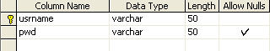

DTP Properties:

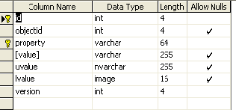

IP Address:

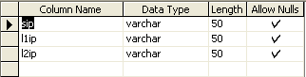

Register:

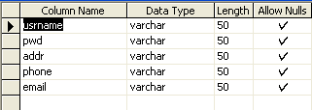

Upload:

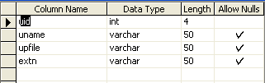

  - FRONT END DESIGN
features of VB.net
Visual Basic. NET, the latest version of visual basic, includes many new features. The Visual Basic supports interfaces but not implementation inheritance.
Visual basic.net supports implementation inheritance, interfaces and overloading. In addition, Visual Basic .NET supports multithreading concept.
COMMON LANGUAGE SPECIFICATION (CLS):

Visual Basic.NET is also compliant with CLS (Common Language Specification) and supports structured exception handling. CLS is set of rules and constructs that are supported by the CLR (Common Language Runtime). CLR is the runtime environment provided by the .NET Framework; it manages the execution of the code and also makes the development process easier by providing services.
Visual Basic.NET is a CLS-compliant language. Any objects, classes, or components that created in Visual Basic.NET can be used in any other CLS-compliant language. In addition, we can use objects, classes, and components created in other CLS-compliant languages in Visual Basic.NET .The use of CLS ensures complete interoperability among applications, regardless of the languages used to create the application.

IMPLEMENTATION INHERITANCE:

Visual Basic.NET supports implementation inheritance. This means that, while creating applications in Visual Basic.NET, we can drive from another class, which is know as the base class that derived class inherits all the methods and properties of the base class. In the derived class, we can either use the existing code of the base class or override the existing code. Therefore, with help of the implementation inheritance, code can be reused.
CONSTRUCTORS AND DESTRUCTORS:
Constructors are used to initialize objects, whereas destructors are used to destroy them. In other words, destructors are used to release the resources allocated to the object. In Visual Basic.NET the sub finalize procedure is available. The sub finalize procedure is used to complete the tasks that must be performed when an object is destroyed. The sub finalize procedure is called automatically when an object is destroyed. In addition, the sub finalize procedure can be called only from the class it belongs to or from derived classes.

GARBAGE COLLECTION:
Garbage Collection is another new feature in Visual Basic.NET. The .NET Framework monitors allocated resources, such as objects and variables. In addition, the .NET Framework automatically releases memory for reuse by destroying objects that are no longer in use. In Visual Basic.NET, the garbage collector checks for the objects that are not currently in use by applications. When the garbage collector comes across an object that is marked for garbage collection, it releases the memory occupied by the object.
OVERLOADING:

Overloading is another feature in Visual Basic.NET. Overloading enables us to define multiple procedures with the same name, where each procedure has a different set of arguments. Besides using overloading for procedures, we can use it for constructors and properties in a class.
MULTITHREADING:

Visual Basic.NET also supports multithreading. An application that supports multithreading can handle multiple tasks simultaneously, we can use multithreading to decrease the time taken by an application to respond to user interaction. To decrease the time taken by an application to respond to user interaction, we must ensure that a separate thread in the application handles user interaction.
STRUCTURED EXCEPTION HANDLING:
Visual Basic.NET supports structured handling, which enables us to detect and remove errors at runtime. In Visual Basic.NET, we need to use Try…Catch…Finally statements to create exception handlers. Using Try…Catch…Finally statements, we can create robust and effective exception handlers to improve the performance of our application.

THE .NET FRAMEWORK:

The .NET Framework is a new computing platform that simplifies application development in the highly distributed environment of the Internet.

Objectives of. NET FRAMEWORK:

1. To provide a consistent object-oriented programming environment whether object codes is stored and executed locally on Internet-distributed, or executed remotely.

2. To provide a code-execution environment to minimizes software deployment and guarantees safe execution of code.

3. Eliminates the performance problems.

There are different types of application, such as Windows-based applications and Web-based applications.

To make communication on distributed environment to ensure that code be accessed by the .NET Framework can integrate with any other code.

VISUAL STUDIO .NET:

Visual Studio .NET is a complete set of development tools for building ASP Web applications, XML Web services, desktop applications, and mobile applications In addition to building high-performing desktop applications, you can use Visual Studio's powerful component-based development tools and other technologies to simplify team-based design, development, and deployment of Enterprise solutions.

Visual Basic .NET, Visual C++ .NET, and Visual C# .NET all use the same integrated development environment (IDE), which allows them to share tools and facilitates in the creation of mixed-language solutions. In addition, these languages leverage the functionality of the .NET Framework and simplify the development of ASP Web applications and XML Web services.

Visual Studio supports the .NET Framework, which provides a common language runtime and unified programming classes; ASP.NET uses these components to create ASP Web applications and XML Web services. Also it includes MSDN Library, which contains all the documentation for these development tools.
  - FEATURES OF SQL SERVER 2005
The OLAP Services feature available in SQL Server version 7.0 is now called SQL Server 2000 Analysis Services. The term OLAP Services has been replaced with the term Analysis Services. Analysis Services also includes a new data mining component. The Repository component available in SQL Server version 7.0 is now called Microsoft SQL Server 2000 Meta Data Services. References to the component now use the term Meta Data Services. The term repository is used only in reference to the repository engine within Meta Data Services
SQL-SERVER database consist of six type of objects,
They are,
1. TABLE
2. QUERY
3. FORM
4. REPORT
5. MACRO

TABLE:
A database is a collection of data about a specific topic.
VIEWS OF TABLE:
We can work with a table in two types,
1. Design View
2. Datasheet View
Design View
To build or modify the structure of a table we work in the table design view. We can specify what kind of data will be hold.
Datasheet View
To add, edit or analyses the data itself we work in tables datasheet view mode.
QUERY:
A query is a question that has to be asked the data. Access gathers data that answers the question from one or more table. The data that make up the answer is either dynaset (if you edit it) or a snapshot(it cannot be edited).Each time we run query, we get latest information in the dynaset.Access either displays the dynaset or snapshot for us to view or perform an action on it ,such as deleting or updating.
FORMS:
A form is used to view and edit information in the database record by record .A form displays only the information we want to see in the way we want to see it. Forms use the familiar controls such as textboxes and checkboxes. This makes viewing and entering data easy.
Views of Form:
They are,
1. Design View
2. Form View
Design View
To build or modify the structure of a form, we work in forms design view. We can add control to the form that are bound to fields in a table or query, includes textboxes, option buttons, graphs and pictures.
Form View
The form view which display the whole design of the form.
REPORT:
A report is used to vies and print information from the database. The report can ground records into many levels and compute totals and average by checking values from many records at once. Also the report is attractive and distinctive because we have control over the size and appearance of it.
MACRO:
A macro is a set of actions. Each action in macros does something. Such as opening a form or printing a report .We write macros to automate the common tasks the work easy and save the time.

Algorithm:
Step 1: Enter the Username and Password for Client
Step 2: The Username and Password is incorrect then create New Registration
Step 3:Login is correct the create IP address
Step 4: Again entern Admin username and password
Step 5: View the excisting IP address or server Name
Step 6: Select IP address and Upload the File
Step 7: Finally view the Network load balancing.

Sample CodingS

Admin Login:
namespace Loadbalancing
{
partial class Admin
{
/// <summary>
/// Required designer variable.
/// </summary>
private System.ComponentModel.IContainer components = null;

/// <summary>
/// Clean up any resources being used.
/// </summary>
/// <param name="disposing">true if managed resources should be disposed; otherwise, false.</param>
protected override void Dispose(bool disposing)
{
if (disposing && (components != null))
{
components.Dispose();
}
base.Dispose(disposing);
}

#region Windows Form Designer generated code

/// <summary>
/// Required method for Designer support - do not modify
/// the contents of this method with the code editor.
/// </summary>
private void InitializeComponent()
{
this.button1 = new System.Windows.Forms.Button();
this.textBox2 = new System.Windows.Forms.TextBox();
this.textBox1 = new System.Windows.Forms.TextBox();
this.label3 = new System.Windows.Forms.Label();
this.label2 = new System.Windows.Forms.Label();
this.label1 = new System.Windows.Forms.Label();
this.button2 = new System.Windows.Forms.Button();
this.SuspendLayout();
//
// button1
//
this.button1.BackColor = System.Drawing.Color.White;
this.button1.Font = new System.Drawing.Font("Palatino Linotype", 14.25F, ((System.Drawing.FontStyle)((System.Drawing.FontStyle.Bold | System.Drawing.FontStyle.Italic))), System.Drawing.GraphicsUnit.Point, ((byte)(0)));
this.button1.ForeColor = System.Drawing.Color.Black;
this.button1.Location = new System.Drawing.Point(113, 194);
this.button1.Name = "button1";
this.button1.Size = new System.Drawing.Size(89, 36);
this.button1.TabIndex = 12;
this.button1.Text = "Submit";
this.button1.UseVisualStyleBackColor = false;
this.button1.Click += new System.EventHandler(this.button1_Click);
//
// textBox2
//
this.textBox2.Location = new System.Drawing.Point(164, 146);
this.textBox2.Name = "textBox2";
this.textBox2.PasswordChar = '*';
this.textBox2.Size = new System.Drawing.Size(100, 20);
this.textBox2.TabIndex = 11;
//
// textBox1
//
this.textBox1.Location = new System.Drawing.Point(164, 115);
this.textBox1.Name = "textBox1";
this.textBox1.Size = new System.Drawing.Size(100, 20);
this.textBox1.TabIndex = 10;
//
// label3
//
this.label3.AutoSize = true;
this.label3.Font = new System.Drawing.Font("Palatino Linotype", 12F, ((System.Drawing.FontStyle)((System.Drawing.FontStyle.Bold | System.Drawing.FontStyle.Italic))), System.Drawing.GraphicsUnit.Point, ((byte)(0)));
this.label3.Location = new System.Drawing.Point(28, 143);
this.label3.Name = "label3";
this.label3.Size = new System.Drawing.Size(133, 21);
this.label3.TabIndex = 9;
this.label3.Text = "Admin Password";
//
// label2
//
this.label2.AutoSize = true;
this.label2.Font = new System.Drawing.Font("Palatino Linotype", 12F, ((System.Drawing.FontStyle)((System.Drawing.FontStyle.Bold | System.Drawing.FontStyle.Italic))), System.Drawing.GraphicsUnit.Point, ((byte)(0)));
this.label2.Location = new System.Drawing.Point(28, 115);
this.label2.Name = "label2";
this.label2.Size = new System.Drawing.Size(100, 21);
this.label2.TabIndex = 8;
this.label2.Text = "Admin name";
//
// label1
//
this.label1.AutoSize = true;
this.label1.BackColor = System.Drawing.Color.CornflowerBlue;
this.label1.Font = new System.Drawing.Font("Palatino Linotype", 20.25F, System.Drawing.FontStyle.Bold, System.Drawing.GraphicsUnit.Point, ((byte)(0)));
this.label1.ForeColor = System.Drawing.Color.Black;
this.label1.Location = new System.Drawing.Point(54, 44);
this.label1.Name = "label1";
this.label1.Size = new System.Drawing.Size(184, 37);
this.label1.TabIndex = 7;
this.label1.Text = "Admin Login";
//
// button2
//
this.button2.Font = new System.Drawing.Font("Microsoft Sans Serif", 8.25F, System.Drawing.FontStyle.Bold, System.Drawing.GraphicsUnit.Point, ((byte)(0)));
this.button2.ForeColor = System.Drawing.Color.Red;
this.button2.Location = new System.Drawing.Point(271, -2);
this.button2.Name = "button2";
this.button2.Size = new System.Drawing.Size(22, 20);
this.button2.TabIndex = 13;
this.button2.Text = "X";
this.button2.UseVisualStyleBackColor = true;
this.button2.Click += new System.EventHandler(this.button2_Click);
//
// Admin
//
this.AutoScaleDimensions = new System.Drawing.SizeF(6F, 13F);
this.AutoScaleMode = System.Windows.Forms.AutoScaleMode.Font;
this.BackColor = System.Drawing.Color.CornflowerBlue;
this.BackgroundImageLayout = System.Windows.Forms.ImageLayout.None;
this.ClientSize = new System.Drawing.Size(292, 266);
this.ControlBox = false;
this.Controls.Add(this.button2);
this.Controls.Add(this.button1);
this.Controls.Add(this.textBox2);
this.Controls.Add(this.textBox1);
this.Controls.Add(this.label3);
this.Controls.Add(this.label2);
this.Controls.Add(this.label1);
this.Name = "Admin";
this.ResumeLayout(false);
this.PerformLayout();

}

#endregion

private System.Windows.Forms.Button button1;
private System.Windows.Forms.TextBox textBox2;
private System.Windows.Forms.TextBox textBox1;
private System.Windows.Forms.Label label3;
private System.Windows.Forms.Label label2;
private System.Windows.Forms.Label label1;
private System.Windows.Forms.Button button2;
}
}

Server 1:

using System;
using System.Collections.Generic;
using System.Net.Sockets;
using System.Net;
using System.Text;

public class Server
{
public static void Main()
{
int recv;
byte[] data = new byte[1024];
string str;

TcpListener newsock = new TcpListener(1111);
newsock.Start();
Console.WriteLine("Waiting for a client...");

TcpClient client = newsock.AcceptTcpClient();
NetworkStream ns = client.GetStream();

while (true)
{
string welcome = "Welcome to my test server";
data = Encoding.ASCII.GetBytes(welcome);
ns.Write(data, 0, data.Length);

recv = ns.Read(data, 0, data.Length);
str=Encoding.ASCII.GetString(data, 0, recv);
Console.WriteLine(str);

if (recv == 0)
break;
}

ns.Close();
client.Close();
newsock.Stop();
}
}

Server 2;

using System;
using System.Collections.Generic;
using System.Net.Sockets;
using System.Net;
using System.Text;

public class Server
{
public static void Main()
{
int recv;
byte[] data = new byte[1024];
string str;

TcpListener newsock = new TcpListener(2222);
newsock.Start();
Console.WriteLine("Waiting for a client...");

TcpClient client = newsock.AcceptTcpClient();
NetworkStream ns = client.GetStream();

while (true)
{
string welcome = "Welcome to my test server";
data = Encoding.ASCII.GetBytes(welcome);
ns.Write(data, 0, data.Length);

recv = ns.Read(data, 0, data.Length);
str=Encoding.ASCII.GetString(data, 0, recv);
Console.WriteLine(str);

if (recv == 0)
break;
}

ns.Close();
client.Close();
newsock.Stop();
}
}

Server 3:

using System;
using System.Collections.Generic;
using System.Net.Sockets;
using System.Net;
using System.Text;

public class Server
{
public static void Main()
{
int recv;
byte[] data = new byte[1024];
string str;

TcpListener newsock = new TcpListener(3333);
newsock.Start();
Console.WriteLine("Waiting for a client...");

TcpClient client = newsock.AcceptTcpClient();
NetworkStream ns = client.GetStream();

while (true)
{
string welcome = "Welcome to my test server";
data = Encoding.ASCII.GetBytes(welcome);
ns.Write(data, 0, data.Length);

recv = ns.Read(data, 0, data.Length);
str=Encoding.ASCII.GetString(data, 0, recv);
Console.WriteLine(str);

if (recv == 0)
break;
}

ns.Close();
client.Close();
newsock.Stop();
}
}

Upload Design Page:

namespace Loadbalancing
{
partial class Upload
{
/// <summary>
/// Required designer variable.
/// </summary>
private System.ComponentModel.IContainer components = null;

/// <summary>
/// Clean up any resources being used.
/// </summary>
/// <param name="disposing">true if managed resources should be disposed; otherwise, false.</param>
protected override void Dispose(bool disposing)
{
if (disposing && (components != null))
{
components.Dispose();
}
base.Dispose(disposing);
}

#region Windows Form Designer generated code

/// <summary>
/// Required method for Designer support - do not modify
/// the contents of this method with the code editor.
/// </summary>
private void InitializeComponent()
{
this.components = new System.ComponentModel.Container();
this.menuStrip = new System.Windows.Forms.MenuStrip();
this.editMenu = new System.Windows.Forms.ToolStripMenuItem();
this.viewMenu = new System.Windows.Forms.ToolStripMenuItem();
this.statusStrip = new System.Windows.Forms.StatusStrip();
this.toolStripStatusLabel = new System.Windows.Forms.ToolStripStatusLabel();
this.ToolTip = new System.Windows.Forms.ToolTip(this.components);
this.exitToolStripMenuItem = new System.Windows.Forms.ToolStripMenuItem();
this.menuStrip.SuspendLayout();
this.statusStrip.SuspendLayout();
this.SuspendLayout();
//
// menuStrip
//
this.menuStrip.Items.AddRange(new System.Windows.Forms.ToolStripItem[] {
this.editMenu,
this.viewMenu,
this.exitToolStripMenuItem});
this.menuStrip.Location = new System.Drawing.Point(0, 0);
this.menuStrip.Name = "menuStrip";
this.menuStrip.Size = new System.Drawing.Size(632, 24);
this.menuStrip.TabIndex = 0;
this.menuStrip.Text = "MenuStrip";
//
// editMenu
//
this.editMenu.Name = "editMenu";
this.editMenu.Size = new System.Drawing.Size(54, 20);
this.editMenu.Text = "Browse";
this.editMenu.Click += new System.EventHandler(this.editMenu_Click);
//
// viewMenu
//
this.viewMenu.Name = "viewMenu";
this.viewMenu.Size = new System.Drawing.Size(52, 20);
this.viewMenu.Text = "Upload";
//
// statusStrip
//
this.statusStrip.Items.AddRange(new System.Windows.Forms.ToolStripItem[] {
this.toolStripStatusLabel});
this.statusStrip.Location = new System.Drawing.Point(0, 431);
this.statusStrip.Name = "statusStrip";
this.statusStrip.Size = new System.Drawing.Size(632, 22);
this.statusStrip.TabIndex = 2;
this.statusStrip.Text = "StatusStrip";
//
// toolStripStatusLabel
//
this.toolStripStatusLabel.Name = "toolStripStatusLabel";
this.toolStripStatusLabel.Size = new System.Drawing.Size(38, 17);
this.toolStripStatusLabel.Text = "Status";
//
// exitToolStripMenuItem
//
this.exitToolStripMenuItem.Name = "exitToolStripMenuItem";
this.exitToolStripMenuItem.Size = new System.Drawing.Size(37, 20);
this.exitToolStripMenuItem.Text = "Exit";
//
// Upload
//
this.AutoScaleDimensions = new System.Drawing.SizeF(6F, 13F);
this.AutoScaleMode = System.Windows.Forms.AutoScaleMode.Font;
this.ClientSize = new System.Drawing.Size(632, 453);
this.Controls.Add(this.statusStrip);
this.Controls.Add(this.menuStrip);
this.IsMdiContainer = true;
this.MainMenuStrip = this.menuStrip;
this.Name = "Upload";
this.Text = "Upload";
this.menuStrip.ResumeLayout(false);
this.menuStrip.PerformLayout();
this.statusStrip.ResumeLayout(false);
this.statusStrip.PerformLayout();
this.ResumeLayout(false);
this.PerformLayout();

}
#endregion

private System.Windows.Forms.MenuStrip menuStrip;
private System.Windows.Forms.StatusStrip statusStrip;
private System.Windows.Forms.ToolStripStatusLabel toolStripStatusLabel;
private System.Windows.Forms.ToolStripMenuItem editMenu;
private System.Windows.Forms.ToolStripMenuItem viewMenu;
private System.Windows.Forms.ToolTip ToolTip;
private System.Windows.Forms.ToolStripMenuItem exitToolStripMenuItem;
}
}

Register Designer:

namespace Loadbalancing
{
partial class Register
{
/// <summary>
/// Required designer variable.
/// </summary>
private System.ComponentModel.IContainer components = null;

/// <summary>
/// Clean up any resources being used.
/// </summary>
/// <param name="disposing">true if managed resources should be disposed; otherwise, false.</param>
protected override void Dispose(bool disposing)
{
if (disposing && (components != null))
{
components.Dispose();
}
base.Dispose(disposing);
}

#region Windows Form Designer generated code

/// <summary>
/// Required method for Designer support - do not modify
/// the contents of this method with the code editor.
/// </summary>
private void InitializeComponent()
{
this.button1 = new System.Windows.Forms.Button();
this.label1 = new System.Windows.Forms.Label();
this.textBox5 = new System.Windows.Forms.TextBox();
this.textBox4 = new System.Windows.Forms.TextBox();
this.textBox3 = new System.Windows.Forms.TextBox();
this.textBox2 = new System.Windows.Forms.TextBox();
this.textBox1 = new System.Windows.Forms.TextBox();
this.label6 = new System.Windows.Forms.Label();
this.label5 = new System.Windows.Forms.Label();
this.label4 = new System.Windows.Forms.Label();
this.label3 = new System.Windows.Forms.Label();
this.label2 = new System.Windows.Forms.Label();
this.button2 = new System.Windows.Forms.Button();
this.SuspendLayout();
//
// button1
//
this.button1.BackColor = System.Drawing.Color.White;
this.button1.Font = new System.Drawing.Font("Palatino Linotype", 12F, ((System.Drawing.FontStyle)((System.Drawing.FontStyle.Bold | System.Drawing.FontStyle.Italic))), System.Drawing.GraphicsUnit.Point, ((byte)(0)));
this.button1.Location = new System.Drawing.Point(151, 312);
this.button1.Name = "button1";
this.button1.Size = new System.Drawing.Size(75, 35);
this.button1.TabIndex = 37;
this.button1.Text = "Submit";
this.button1.UseVisualStyleBackColor = false;
this.button1.Click += new System.EventHandler(this.button1_Click);
//
// label1
//
this.label1.AutoSize = true;
this.label1.Font = new System.Drawing.Font("Palatino Linotype", 18F, System.Drawing.FontStyle.Bold, System.Drawing.GraphicsUnit.Point, ((byte)(0)));
this.label1.Location = new System.Drawing.Point(54, 37);
this.label1.Name = "label1";
this.label1.Size = new System.Drawing.Size(289, 32);
this.label1.TabIndex = 26;
this.label1.Text = "New User? Register Here";
//
// textBox5
//
this.textBox5.Location = new System.Drawing.Point(212, 266);
this.textBox5.Name = "textBox5";
this.textBox5.Size = new System.Drawing.Size(100, 20);
this.textBox5.TabIndex = 36;
//
// textBox4
//
this.textBox4.Location = new System.Drawing.Point(212, 228);
this.textBox4.Name = "textBox4";
this.textBox4.Size = new System.Drawing.Size(100, 20);
this.textBox4.TabIndex = 35;
//
// textBox3
//
this.textBox3.Location = new System.Drawing.Point(212, 186);
this.textBox3.Multiline = true;
this.textBox3.Name = "textBox3";
this.textBox3.Size = new System.Drawing.Size(100, 20);
this.textBox3.TabIndex = 34;
//
// textBox2
//
this.textBox2.Location = new System.Drawing.Point(212, 148);
this.textBox2.Name = "textBox2";
this.textBox2.PasswordChar = '*';
this.textBox2.Size = new System.Drawing.Size(100, 20);
this.textBox2.TabIndex = 33;
//
// textBox1
//
this.textBox1.Location = new System.Drawing.Point(212, 110);
this.textBox1.Name = "textBox1";
this.textBox1.Size = new System.Drawing.Size(100, 20);
this.textBox1.TabIndex = 32;
//
// label6
//
this.label6.AutoSize = true;
this.label6.Font = new System.Drawing.Font("Palatino Linotype", 12F, ((System.Drawing.FontStyle)((System.Drawing.FontStyle.Bold | System.Drawing.FontStyle.Italic))), System.Drawing.GraphicsUnit.Point, ((byte)(0)));
this.label6.Location = new System.Drawing.Point(76, 263);
this.label6.Name = "label6";
this.label6.Size = new System.Drawing.Size(52, 21);
this.label6.TabIndex = 31;
this.label6.Text = "Email";
//
// label5
//
this.label5.AutoSize = true;
this.label5.Font = new System.Drawing.Font("Palatino Linotype", 12F, ((System.Drawing.FontStyle)((System.Drawing.FontStyle.Bold | System.Drawing.FontStyle.Italic))), System.Drawing.GraphicsUnit.Point, ((byte)(0)));
this.label5.Location = new System.Drawing.Point(76, 225);
this.label5.Name = "label5";
this.label5.Size = new System.Drawing.Size(115, 21);
this.label5.TabIndex = 30;
this.label5.Text = "Phone Number";
//
// label4
//
this.label4.AutoSize = true;
this.label4.Font = new System.Drawing.Font("Palatino Linotype", 12F, ((System.Drawing.FontStyle)((System.Drawing.FontStyle.Bold | System.Drawing.FontStyle.Italic))), System.Drawing.GraphicsUnit.Point, ((byte)(0)));
this.label4.Location = new System.Drawing.Point(76, 186);
this.label4.Name = "label4";
this.label4.Size = new System.Drawing.Size(67, 21);
this.label4.TabIndex = 29;
this.label4.Text = "Address";
//
// label3
//
this.label3.AutoSize = true;
this.label3.Font = new System.Drawing.Font("Palatino Linotype", 12F, ((System.Drawing.FontStyle)((System.Drawing.FontStyle.Bold | System.Drawing.FontStyle.Italic))), System.Drawing.GraphicsUnit.Point, ((byte)(0)));
this.label3.Location = new System.Drawing.Point(76, 145);
this.label3.Name = "label3";
this.label3.Size = new System.Drawing.Size(81, 21);
this.label3.TabIndex = 28;
this.label3.Text = "Password";
//
// label2
//
this.label2.AutoSize = true;
this.label2.Font = new System.Drawing.Font("Palatino Linotype", 12F, ((System.Drawing.FontStyle)((System.Drawing.FontStyle.Bold | System.Drawing.FontStyle.Italic))), System.Drawing.GraphicsUnit.Point, ((byte)(0)));
this.label2.Location = new System.Drawing.Point(76, 107);
this.label2.Name = "label2";
this.label2.Size = new System.Drawing.Size(87, 21);
this.label2.TabIndex = 27;
this.label2.Text = "User Name";
//
// button2
//
this.button2.Font = new System.Drawing.Font("Microsoft Sans Serif", 8.25F, System.Drawing.FontStyle.Bold, System.Drawing.GraphicsUnit.Point, ((byte)(0)));
this.button2.ForeColor = System.Drawing.Color.Red;
this.button2.Location = new System.Drawing.Point(383, -1);
this.button2.Name = "button2";
this.button2.Size = new System.Drawing.Size(22, 20);
this.button2.TabIndex = 38;
this.button2.Text = "X";
this.button2.UseVisualStyleBackColor = true;
this.button2.Click += new System.EventHandler(this.button2_Click);
//
// Register
//
this.AutoScaleDimensions = new System.Drawing.SizeF(6F, 13F);
this.AutoScaleMode = System.Windows.Forms.AutoScaleMode.Font;
this.BackColor = System.Drawing.Color.CornflowerBlue;
this.ClientSize = new System.Drawing.Size(404, 358);
this.ControlBox = false;
this.Controls.Add(this.button2);
this.Controls.Add(this.button1);
this.Controls.Add(this.label1);
this.Controls.Add(this.textBox5);
this.Controls.Add(this.textBox4);
this.Controls.Add(this.textBox3);
this.Controls.Add(this.textBox2);
this.Controls.Add(this.textBox1);
this.Controls.Add(this.label6);
this.Controls.Add(this.label5);
this.Controls.Add(this.label4);
this.Controls.Add(this.label3);
this.Controls.Add(this.label2);
this.Name = "Register";
this.Load += new System.EventHandler(this.Form1_Load);
this.ResumeLayout(false);
this.PerformLayout();

}

#endregion

private System.Windows.Forms.Button button1;
private System.Windows.Forms.Label label1;
private System.Windows.Forms.TextBox textBox5;
private System.Windows.Forms.TextBox textBox4;
private System.Windows.Forms.TextBox textBox3;
private System.Windows.Forms.TextBox textBox2;
private System.Windows.Forms.TextBox textBox1;
private System.Windows.Forms.Label label6;
private System.Windows.Forms.Label label5;
private System.Windows.Forms.Label label4;
private System.Windows.Forms.Label label3;
private System.Windows.Forms.Label label2;
private System.Windows.Forms.Button button2;
}
}

Register:

using System;
using System.Collections.Generic;
using System.ComponentModel;
using System.Data;
using System.Drawing;
using System.Text;
using System.Windows.Forms;
using System.Data.SqlClient;

namespace Loadbalancing
{
public partial class Register : Form
{
public Register()
{
InitializeComponent();
}
SqlConnection objConnect = new SqlConnection("server=.;uid=sa;database=ssl");
SqlCommand objCommand;

private void Form1_Load(object sender, EventArgs e)
{

}

private void button1_Click(object sender, EventArgs e)
{
{
if (textBox1.Text == "" || textBox2.Text == "" || textBox3.Text == "" || textBox4.Text == "" || textBox5.Text == "")
{
MessageBox.Show("Please Enter all the Columns and then Click Submit");
}
else
{
objConnect.Open();
objCommand = new SqlCommand("reg", objConnect);
objCommand.CommandType = CommandType.StoredProcedure;
objCommand.Parameters.AddWithValue("@usrname", textBox1.Text);
objCommand.Parameters.AddWithValue("@pwd", textBox2.Text);
objCommand.Parameters.AddWithValue("@addr", textBox3.Text);
objCommand.Parameters.AddWithValue("@phone", textBox4.Text);
objCommand.Parameters.AddWithValue("@email", textBox5.Text);
objCommand.ExecuteNonQuery();
objConnect.Close();

textBox1.Text = "";
textBox2.Text = "";
textBox3.Text = "";
textBox4.Text = "";
textBox5.Text = "";
MessageBox.Show("Values are inserted");
Register reg = new Register();
this.Hide();

}
}
}

private void button2_Click(object sender, EventArgs e)
{
this.Hide();
}
}
}

View Designer:

namespace Loadbalancing
{
partial class ViewFiles
{
/// <summary>
/// Required designer variable.
/// </summary>
private System.ComponentModel.IContainer components = null;

/// <summary>
/// Clean up any resources being used.
/// </summary>
/// <param name="disposing">true if managed resources should be disposed; otherwise, false.</param>
protected override void Dispose(bool disposing)
{
if (disposing && (components != null))
{
components.Dispose();
}
base.Dispose(disposing);
}

#region Windows Form Designer generated code

/// <summary>
/// Required method for Designer support - do not modify
/// the contents of this method with the code editor.
/// </summary>
private void InitializeComponent()
{
this.listBox1 = new System.Windows.Forms.ListBox();
this.button1 = new System.Windows.Forms.Button();
this.button2 = new System.Windows.Forms.Button();
this.SuspendLayout();
//
// listBox1
//
this.listBox1.FormattingEnabled = true;
this.listBox1.Location = new System.Drawing.Point(87, 19);
this.listBox1.Name = "listBox1";
this.listBox1.Size = new System.Drawing.Size(120, 173);
this.listBox1.TabIndex = 0;
//
// button1
//
this.button1.BackColor = System.Drawing.Color.White;
this.button1.Location = new System.Drawing.Point(106, 212);
this.button1.Name = "button1";
this.button1.Size = new System.Drawing.Size(75, 23);
this.button1.TabIndex = 1;
this.button1.Text = "Process";
this.button1.UseVisualStyleBackColor = false;
this.button1.Click += new System.EventHandler(this.button1_Click);
//
// button2
//
this.button2.Font = new System.Drawing.Font("Microsoft Sans Serif", 8.25F, System.Drawing.FontStyle.Bold, System.Drawing.GraphicsUnit.Point, ((byte)(0)));
this.button2.ForeColor = System.Drawing.Color.Red;
this.button2.Location = new System.Drawing.Point(271, -1);
this.button2.Name = "button2";
this.button2.Size = new System.Drawing.Size(22, 20);
this.button2.TabIndex = 15;
this.button2.Text = "X";
this.button2.UseVisualStyleBackColor = true;
this.button2.Click += new System.EventHandler(this.button2_Click);
//
// ViewFiles
//
this.AutoScaleDimensions = new System.Drawing.SizeF(6F, 13F);
this.AutoScaleMode = System.Windows.Forms.AutoScaleMode.Font;
this.BackColor = System.Drawing.Color.CornflowerBlue;
this.ClientSize = new System.Drawing.Size(292, 249);
this.ControlBox = false;
this.Controls.Add(this.button2);
this.Controls.Add(this.button1);
this.Controls.Add(this.listBox1);
this.Name = "ViewFiles";
this.Load += new System.EventHandler(this.ViewFiles_Load);
this.ResumeLayout(false);

}

#endregion

private System.Windows.Forms.ListBox listBox1;
private System.Windows.Forms.Button button1;
private System.Windows.Forms.Button button2;
}
}

CHAPTER 8
SYSTEM TESTING

8.1 Unit Testing

The procedure level testing is made first. By giving improper inputs, the errors occurred are noted and eliminated. Then the web form level testing is made. For example storage of data to the table in the correct manner.

The dates are entered in wrong manner and checked. Wrong email-id and web site URL (Universal Resource Locator) is given and checked.

8.2 Integration Testing

Testing is done for each module. After testing all the modules, the modules are integrated and testing of the final system is done with the test data, specially designed to show that the system will operate successfully in all its aspects conditions. Thus the system testing is a confirmation that all is correct and an opportunity to show the user that the system works.

8.3 Validation Testing

The final step involves Validation testing, which determines whether the software function as the user expected. The end-user rather than the system developer conduct this test most software developers as a process called “Alpha and Beta Testing” to uncover that only the end user seems able to find.

The compilation of the entire project is based on the full satisfaction of the end users. In the project, validation testing is made in various forms. In registration form Email id, phone number and also mandatory fields for the user is verified.

8.4 Verification Testing
Verification is a fundamental concept in software design. This is the bridge between customer requirements and an implementation that satisfies those requirements.
This is verifiable if it can be demonstrated that the testing will result in an implementation that satisfies the customer requirements.
Inadequate testing or non-testing leads to errors that may appear few months later. This will create two problems

- Time delay between the cause and appearance of the problem.
- The effect of the system errors on files and records within the system.
Maintenance
The objectives of this maintenance work are to make sure that the system gets into work all time without any bug. Provision must be for environmental changes which may affect the computer or software system. This is called the maintenance of the system. Nowadays there is the rapid change in the software world. Due to this rapid change, the system should be capable of adapting these changes. In our project the process can be added without affecting other parts of the system.

8.5 User Acceptance Testing

User acceptance testing of a system is the key factor of the success of any system. The system under study is tested for the user acceptance by constantly keeping in touch with the prospective system users at any time of developing and making changes whenever required.

CHAPTER 9

PROBLEMS FACED

When there is a clear goal in sight but no clear set of directions or means to attain that goal, then it is called a problem. problems can be broken down into four aspects; goal, givens, means of transforming conditions, and obstacles.
Goal – the goal is the desired end state which the problem solving is being directed toward.
The hope is to reach that end state and be able to assess whether or not you achieved what you wanted.
Givens- these are the objects , conditions ,and constraints that accompany a problem ,and can be either explicit or implicit.
Means of transforming conditions- there should be a way of changing the initial stateof the problem.this is most usually a person’s knowledge or skill level. For instance ,a computer programmer presented with a problem would utilize his or her knowledge of programming language to transform the state of the problem.
Obstacles- the problem should present a challenge.if there are no challenges involved and the situation can be easily solved then it is not so a problem so much as a rountine task.
Every problem has a problem faced, which is the whole range of possible states and operators.only some of these states and operators will bring the person closer to the goal state. The problem starts at the initial state and operators are applied to change the state, creating a series of intermediate states that should hopefully lead to the final goal state

Future Plan

The project has covered almost all the requirements. Further requirements and improvements can easily be done since the coding is mainly structured or modular in nature. Improvements can be appended by changing the existing modules or adding new modules. One important development that can be added to the project in future is file level backup, which is presently done for folder level.

8. CONCLUSION

It is concluded that the application works well and satisfy the needs. The application is tested very well and errors are properly debugged. It also acts as the managements Systems to the valuable resources.

The issue date and returned date of books is updated at the database automatically at the time of enter by the Liberian. Additional checking whether the book is available in the library at that time is done by the system automatically; the backup is made automatically at the system startup. The speed of the transactions become more enough now.

APPENDIX

Home Page:

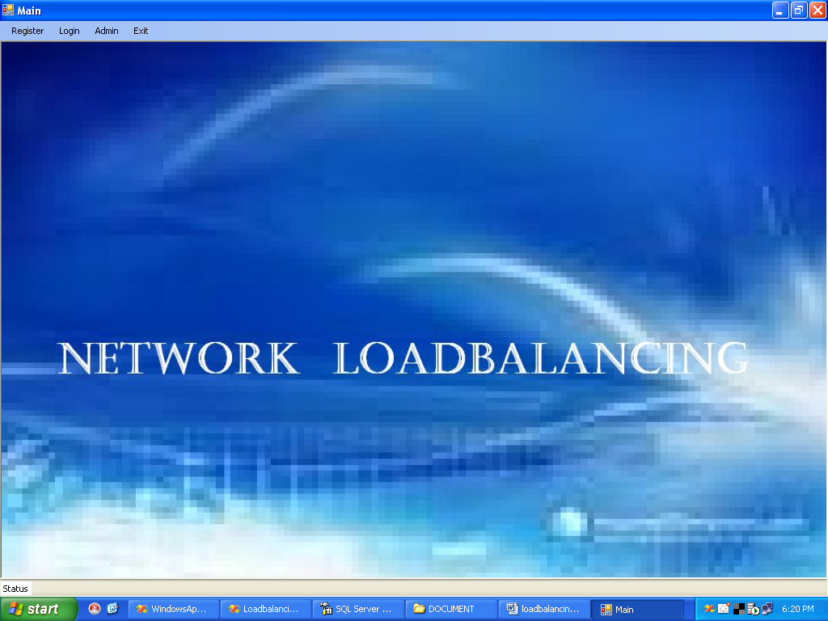

New User Registration:

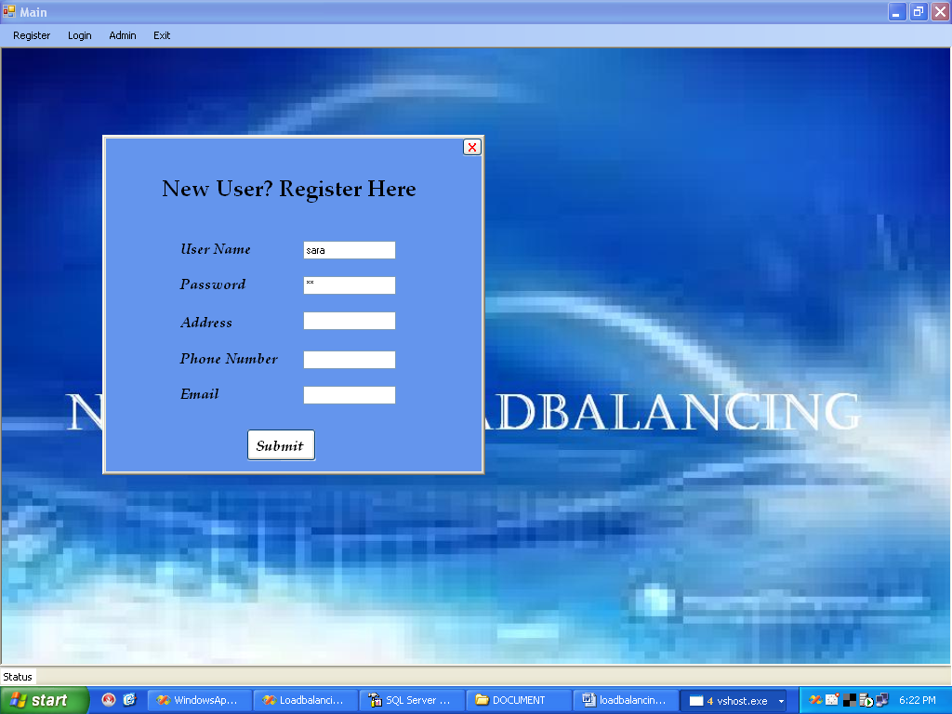

User Login:

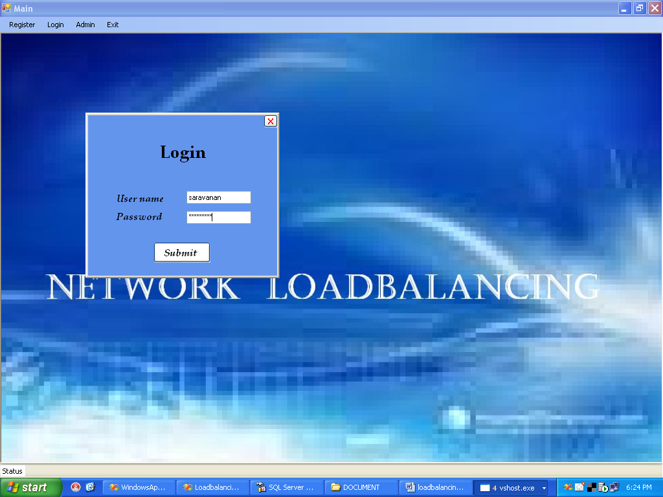

Admin Login:

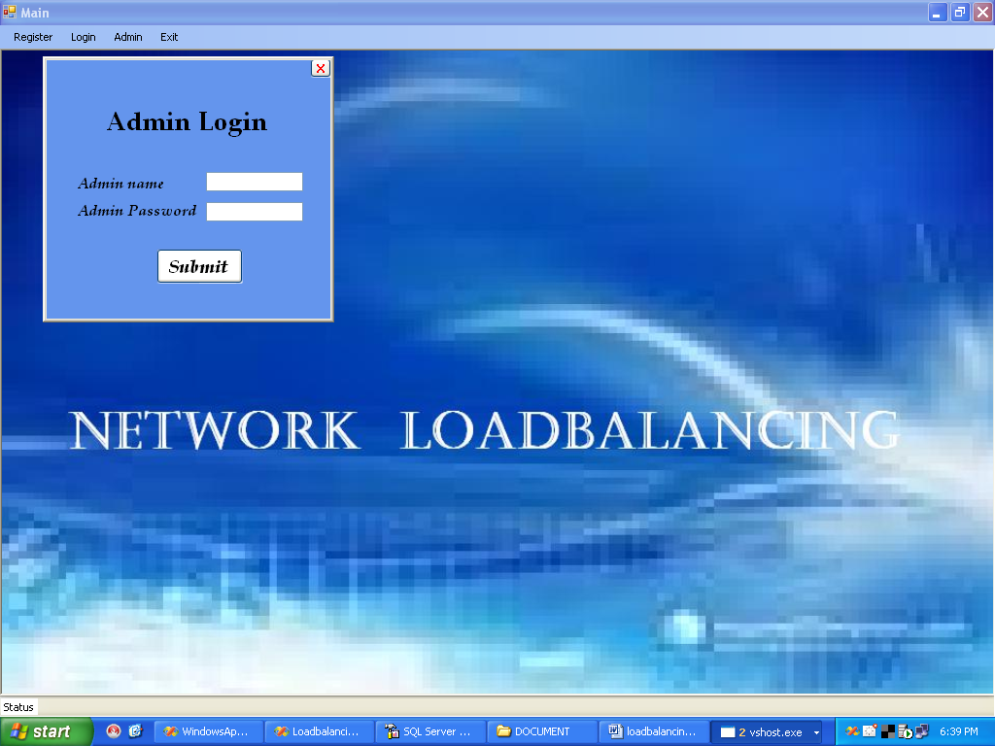

Admin Module:

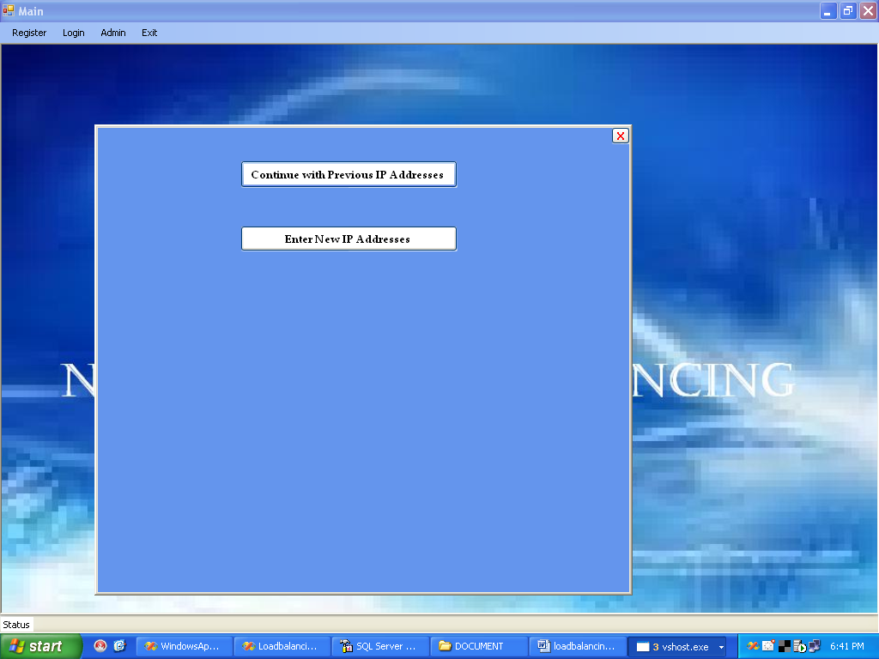

Previous Ip Address:

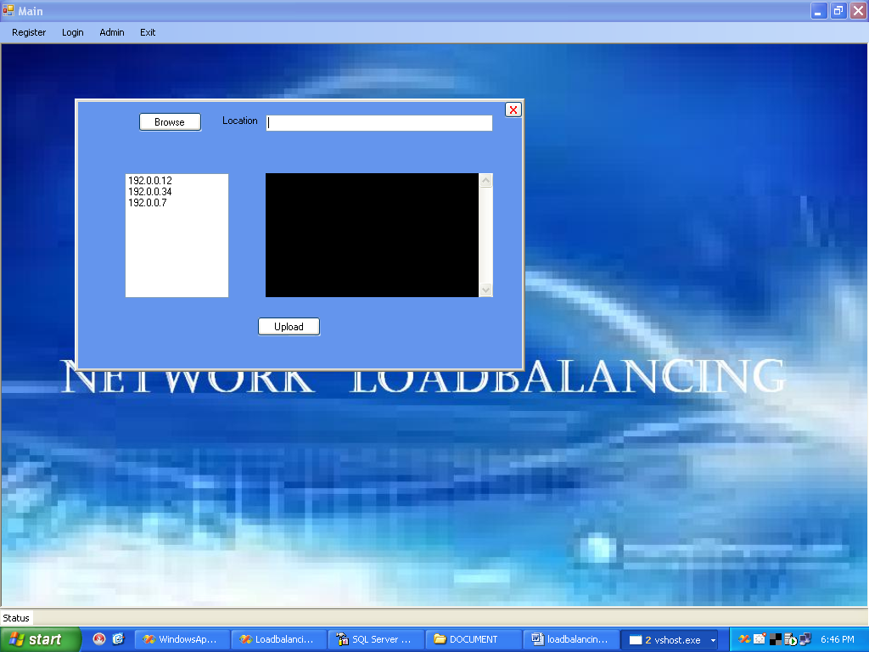

New IP Address:

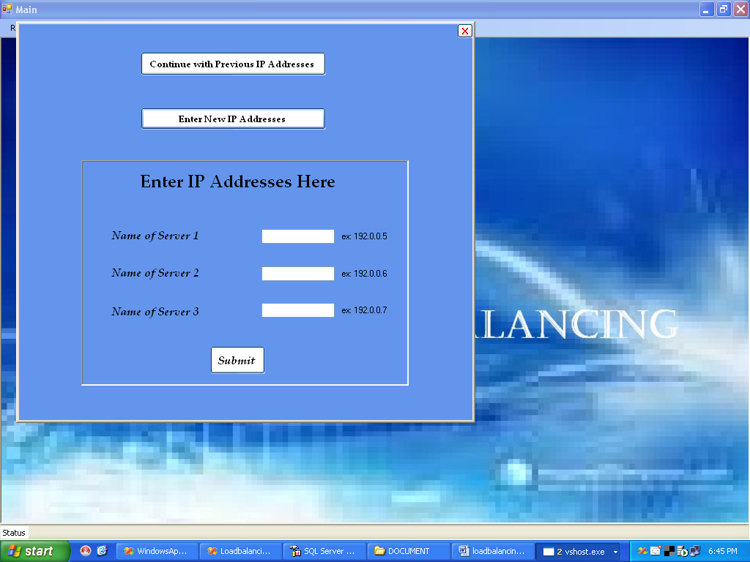

View File:

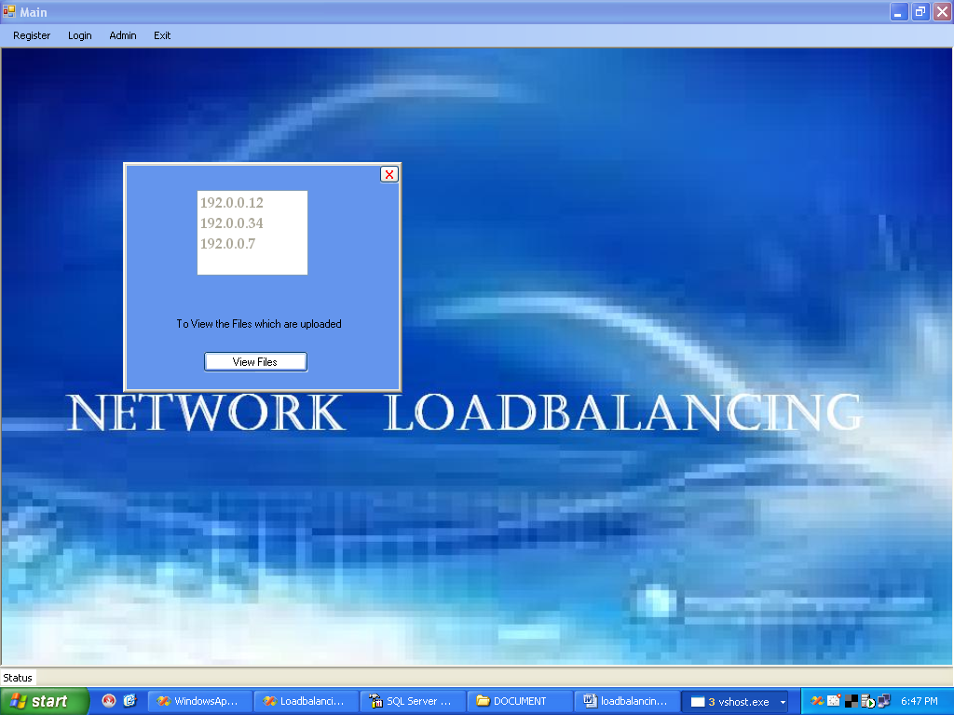

9. References

1. Microsoft Visual Basic.NET Programmer’s Cook Book:
-MATTHEW MACDONALD
(Tata McGraw Hill Edition)

2.Grey Buczek, .NET developers guide 2002, Prentice-Hall India.

3. Benolt Marchal, VB.NET by example 2003 – TataMcGraw- Hill.

4. System Analysis & Design – Alenis Leon.

5. An Integral approach to software engineering – Pankaj Jalole.

BIBLIOGRAPHY

- www.codeproject.com/KB/custom-controls/asppopup.aspx
- http://www.developerfusion.com/code/4673/programatically-load-user-controls/
- http://www.developerfusion.com/code/4596/how-to-access-a-mysql-database-with-net/
- http://www.developerfusion.com/code/3826/adding-controls-to-placeholders-dynamically/
- http://aspalliance.com/1125_Dynamically_Templated_GridView_with_Edit_Delete_and_Insert_Options
- www.codeproject.com/KB/custom-controls/asppopup.aspx
- http://www.developerfusion.com/code/4673/programatically-load-user-controls/
- http://www.developerfusion.com/code/4596/how-to-access-a-mysql-database-with-net/
- http://www.developerfusion.com/code/3826/adding-controls-to-placeholders-dynamically/
- http://aspalliance.com/1125_Dynamically_Templated_GridView_with_Edit_Delete_and_Insert_Options

